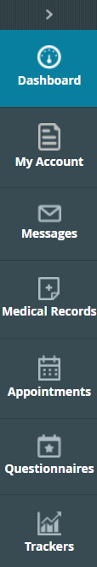
Navigating the Home Page & Menu

Menu Band

A menu band displays on the left side of the Home Page.

Patients can access the following sections:

- Dashboard: The Dashboard displays a key message from the practice, the number of medications, and more.

Medical Records: This section gives patients access to their medical records, such as visit summaries, PHR, lab/DI results, referrals, and Immunization histories.

- My Account: This section gives patients access to their account information.

- Messages: This section gives patients access to their messages.

- Appointments: This section enables patients to request a new appointment, to see the date and time of scheduled appointments, and to display a list of previous appointments.

Dashboard & Medical Records

The Dashboard gives patients a concise and user-friendly view of the information available in the Portal.
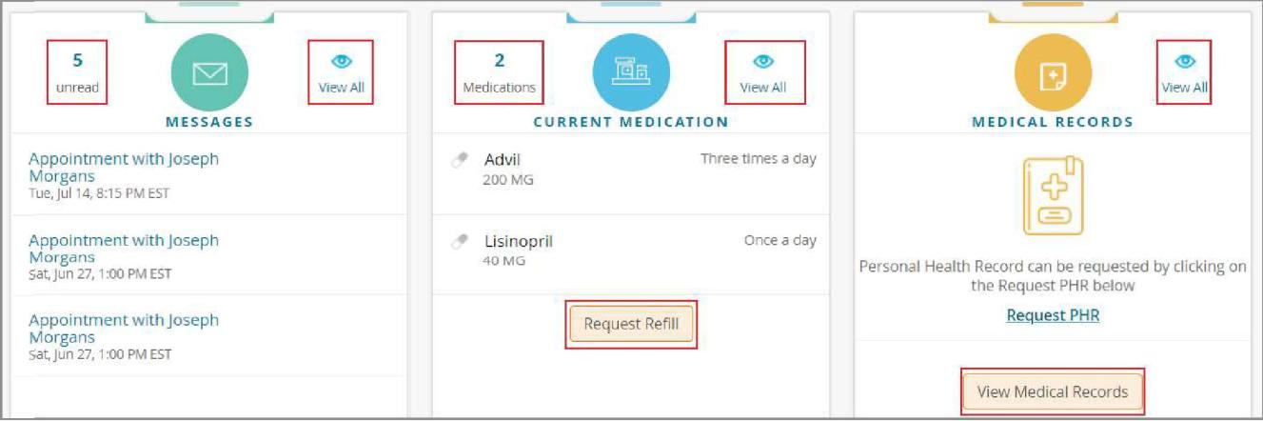

My Account
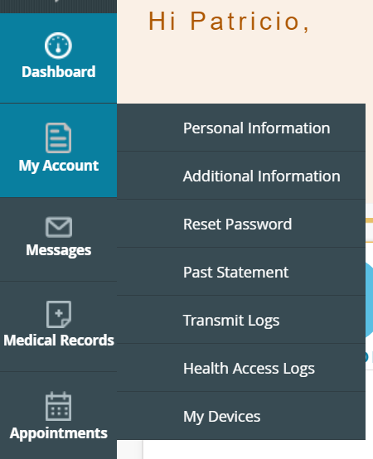
The My Account section enables patients to reset their passwords, view various logs (transmit, transactional, document access, or account access) if any, and access and/or update their personal or additional information, such as mailing/billing addresses, preferred pharmacies, emergency contact information, and more.

Personal Information

The PERSONAL INFORMATION page enables users to update their address, marital status, gender, contact details, PCP, and more:

Additional Information

The ADDITIONAL INFORMATION page enables users to update any additional information, such as pharmacy changes, addresses that may be different from mailing addresses, employer information,
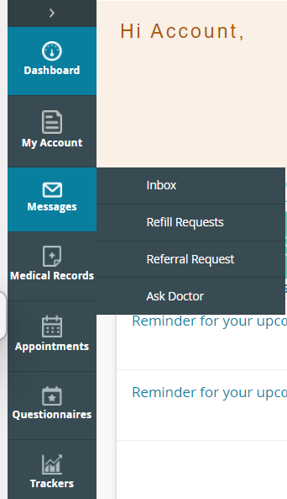
and any additional contact information:

Messages

Inbox

Click lnbox to display a list of messages currently in their inbox.

Press “Compose” to generate a new message to send to the provider.

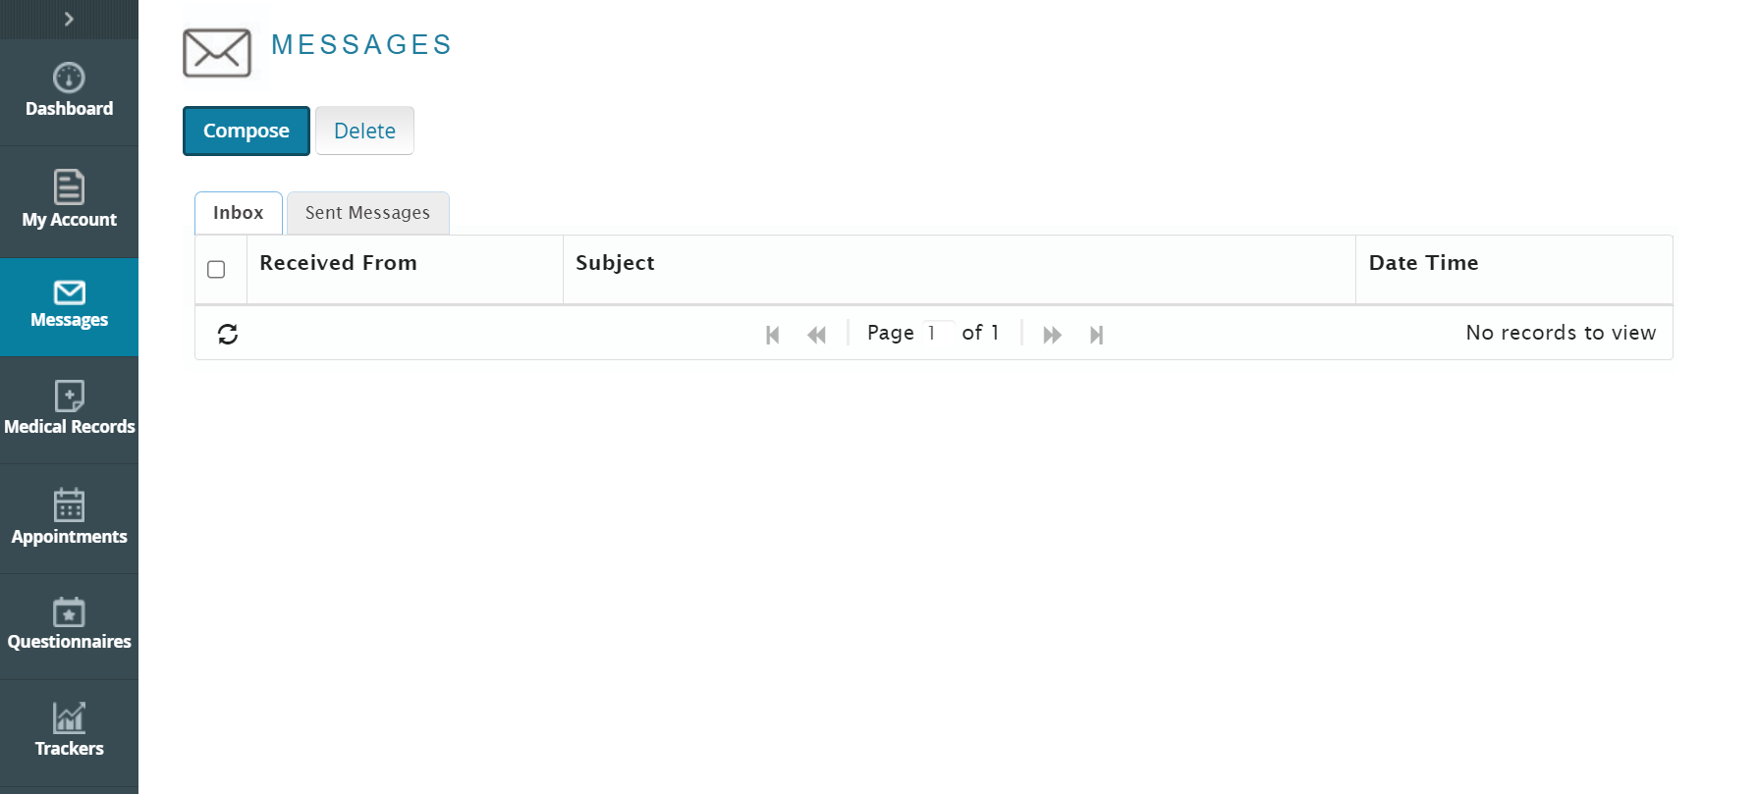

Refill Requests

Click “Refill Requests” to display a list with all your medications

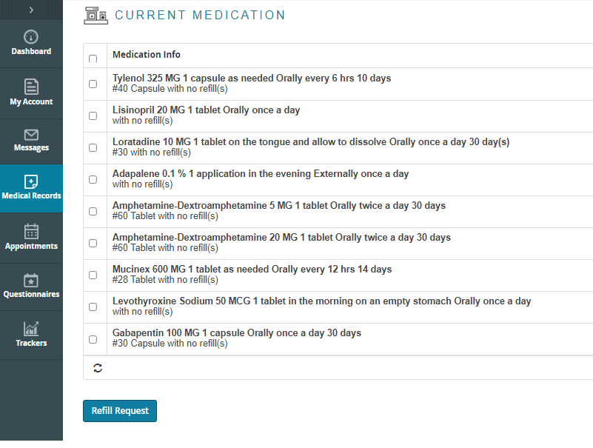
Select the medication(s) that you need refilled and then press the refill request button in the bottom left of the window.

The dropdown menus will allow you to select your provider, medical facility, and the pharmacy you would like your medication sent to, along with the ability to make any necessary comments. Once completed, click submit.
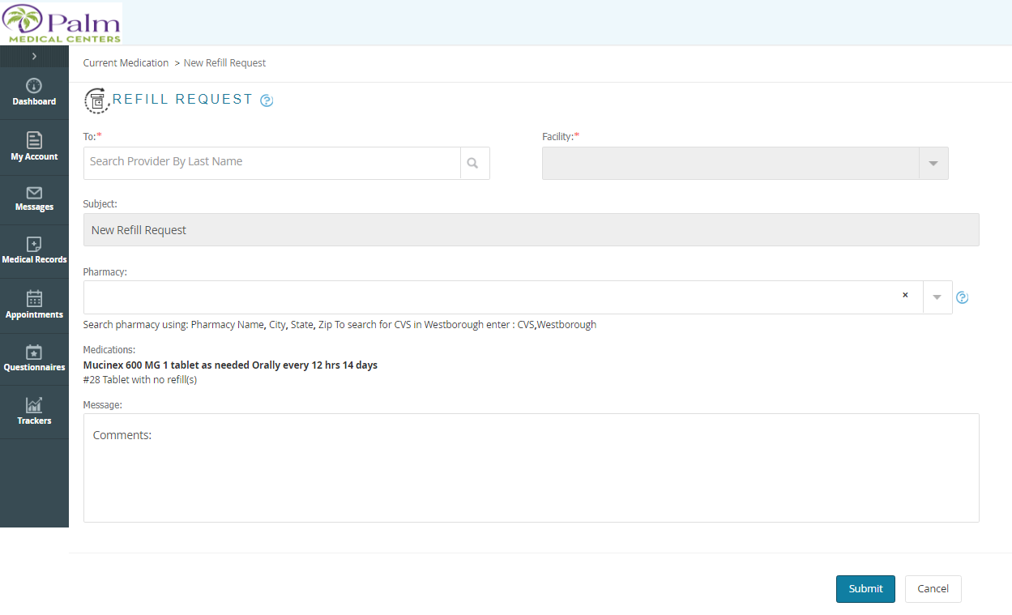

Referral Request

Click “Referral Requests” to display a list of all your referrals

***Not able to request a new referral. ***

Appointments/Upcoming Appointments

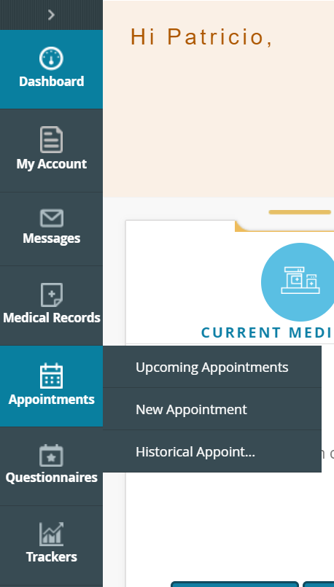

Click “Upcoming appointments in the Appointments section to view upcoming appointments.

The upcoming appointments detail screen allows you to check-in, reschedule or cancel appointments.
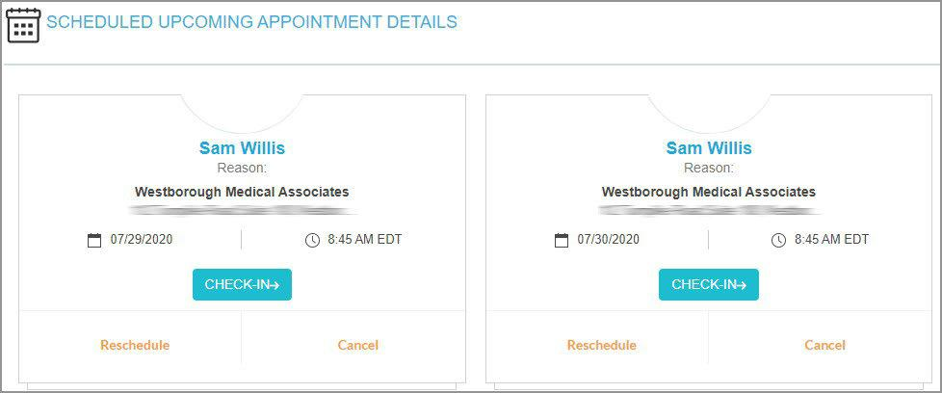

.

New Appointments

Select “New Appointments” to schedule a new appointment.

Once you select New Appointment, it will ask you to select a specialty or to select your provider. Once selected, click next.
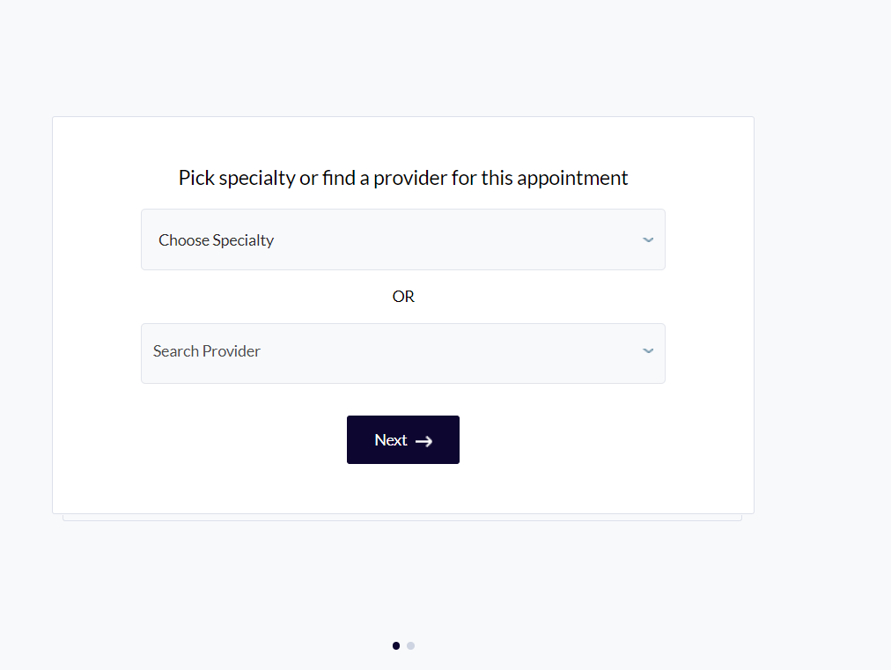
You will then be prompted to choose your home facility. 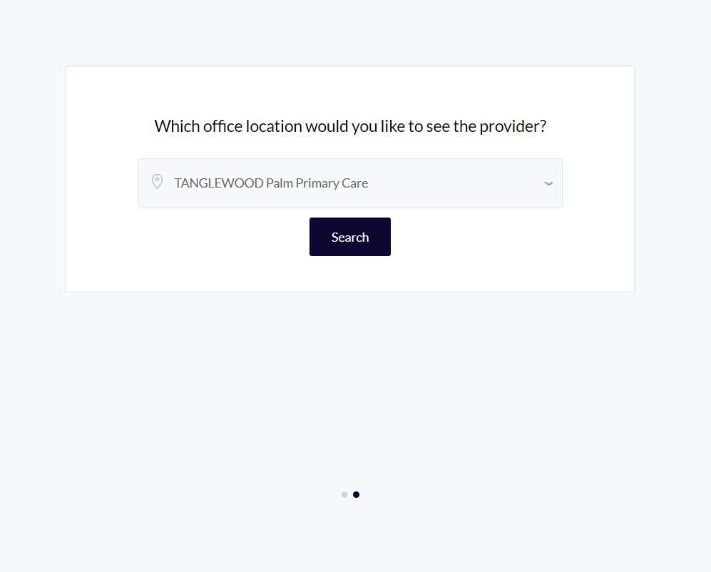

When you hit search, you will be taken to a page where you can see the provider availability as well as practice location on a map. Select show availability from the your provider’s profile, and then select an appointment reason.
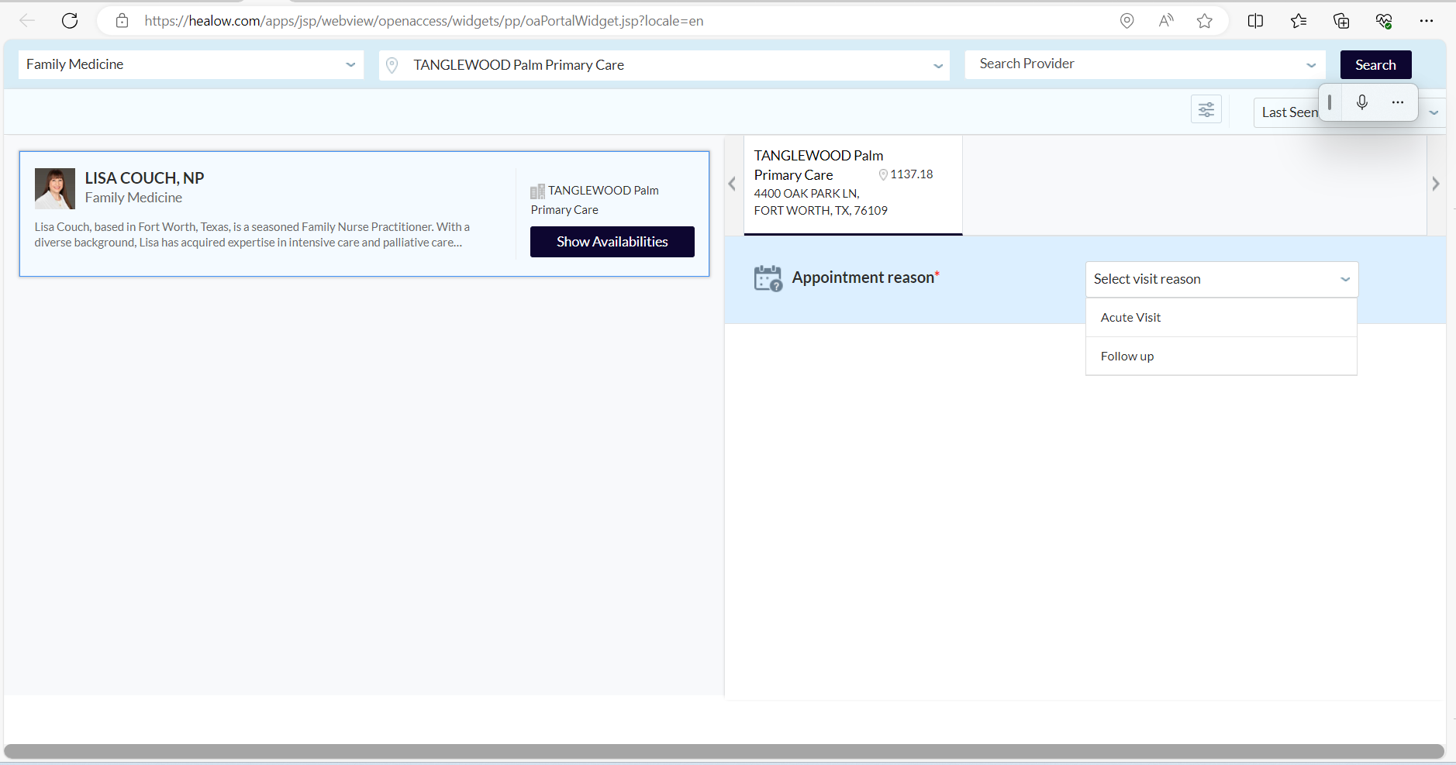
Times will populate according to the provider’s availability. Select the time that works best for you.
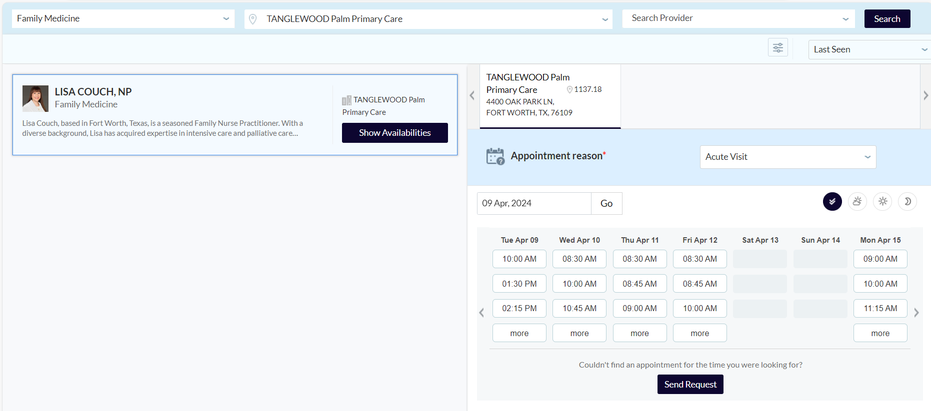

If you are unable to find a time that works, please hit Send Request at the bottom of the schedule.
If you do select a time, the system will populate your patient info, and give you the ability to update your phone number, confirm appointment details, send a note to your provider, and provide insurance information if it is not already in the system.
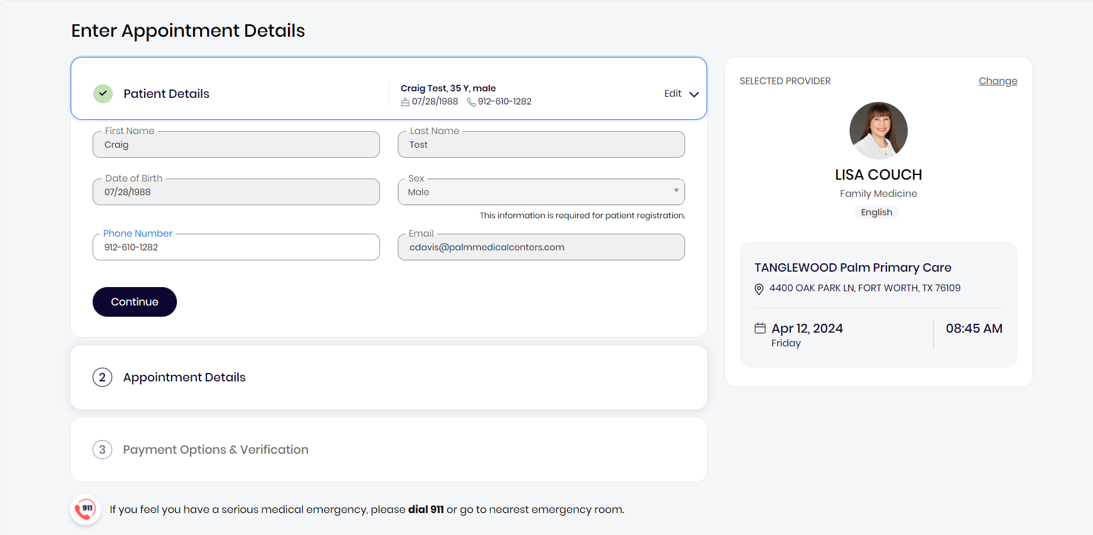
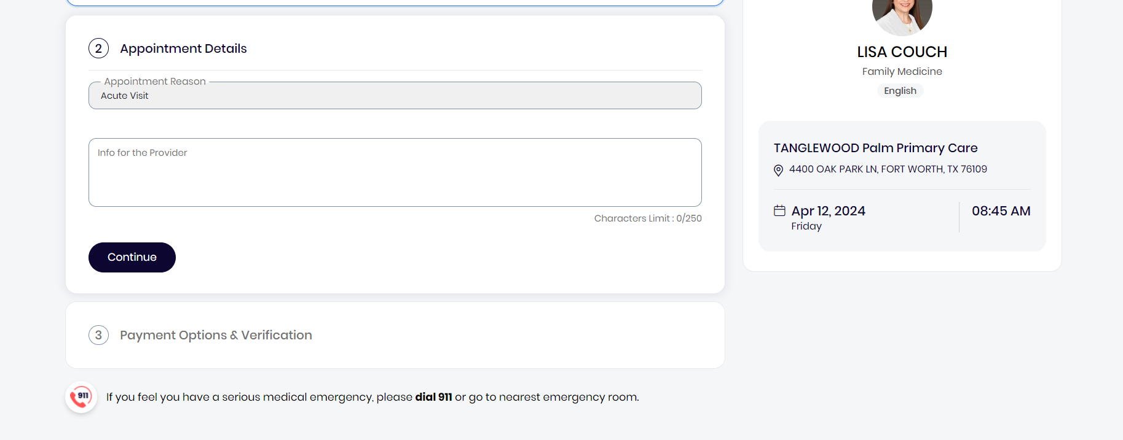

After adding insurance details if necessary, you will be asked to verify your phone number
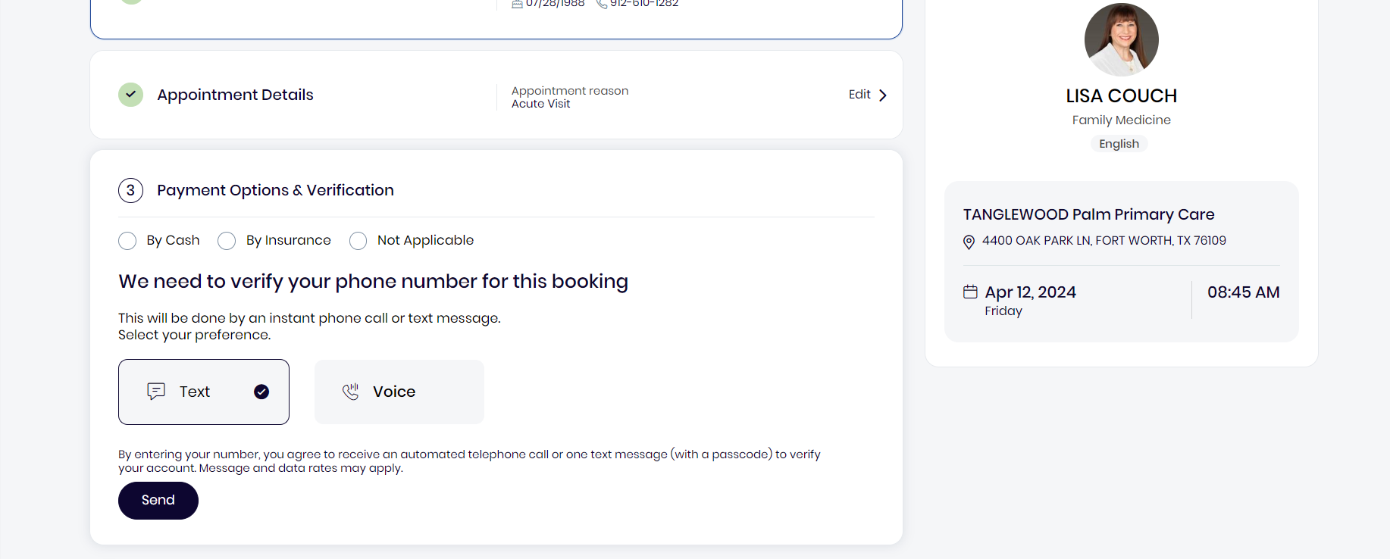
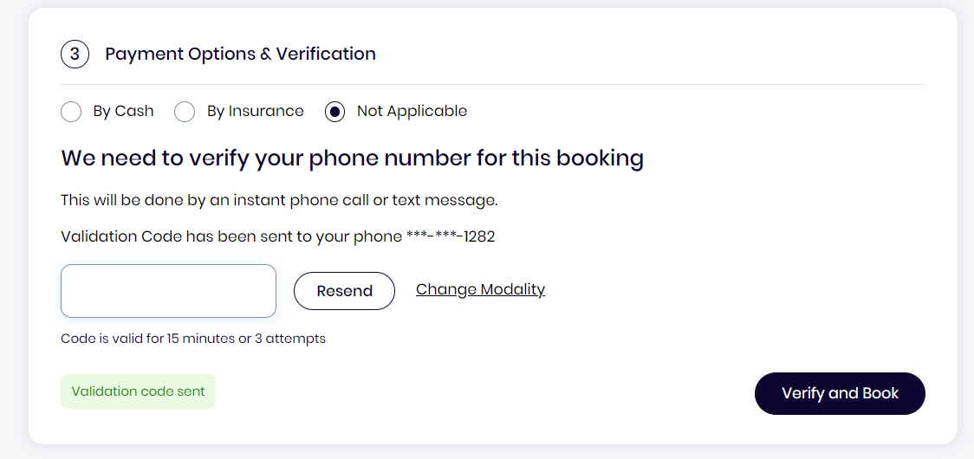
Once you receive the code, click verify and book, and you will also get a confirmation email that your appointment has been booked.

